# **Kafka local setup**

. means current directory

--Double hyphen means predefined key

Windows means use backward slash

|  |  |
| --- | --- |
| Windows | Mac |
| %KAFKA_HOME%  Whereas KAFKA_HOME is an environment variable | $KAFKA_HOME |
| Use BACK slash \ | Forward slash / |
| .bat | .sh |
| .. means current directory |  |
| .also sometimes current directory- I am also not clear |  |

Download kafka from kafka quickstart

And make sure u have the kafka in c folder

1. Start zookeeper

First always Start zookeeper with zookeeper properties file

Always run the command outside bin folder because u need to provide the properties files which are in config folder which is outside of bin folder –so don’t run commands inside bin folder

**Way1 without using dot :-**

E:\study softwares\kafka-3.3.1-src>bin\windows\zookeeper-server-start.bat config\zookeeper.properties

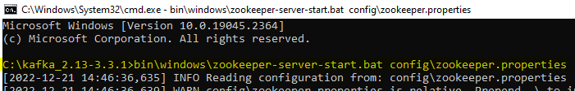

Move the Kafka folder to c drive and start the zookeeper and its working initially when it was in e drive it was having class path issue now its solved after moving

**Way 2 with using dot .\ :-**

C:\kafka_2.13-3.3.1>.\bin\windows\zookeeper-server-start.bat .\config\zookeeper.properties

The above command says, there is a batch file called zookeeper-server-start.bat

In bin/windows folder run that batch file using zookeeper.properties which is present in config folder

If u got any error like below

Classpath is empty. Please build the project first e.g. by running 'gradlew jarAll'

Then goto bin\windows\kafka-run-class

1. Start kafka server with server.properties file

C:\kafka_2.13-3.3.1>bin\windows\kafka-server-start.bat config\server.properties

Start the kafka with server.properties file

Once started u wil text with port number as “PLAINTEXT://DESKTOP-48ALSQ8:9092,”

1. Create the topic

.\bin\windows\kafka-topics.bat --create --topic myTopic --partitions 1 –replication-factor 1 --bootstrap-server localhost:9092

1. Create the console producer

.\bin\windows\kafka-console-producer.bat --topic myTopic --bootstrap-server localhost:9092

Create a producer and gave a sample csv file as below then the producer will put that file to the kafka server

.\bin\windows\kafka-console-producer.bat --topics myTopic --bootstrap-server localhost:9092 < ..\data\sample2.csv

1. Create console consumer

.\bin\windows\kafka-console-consumer.bat --topic myTopic --bootstrap-server localhost:9092 --from-beginning

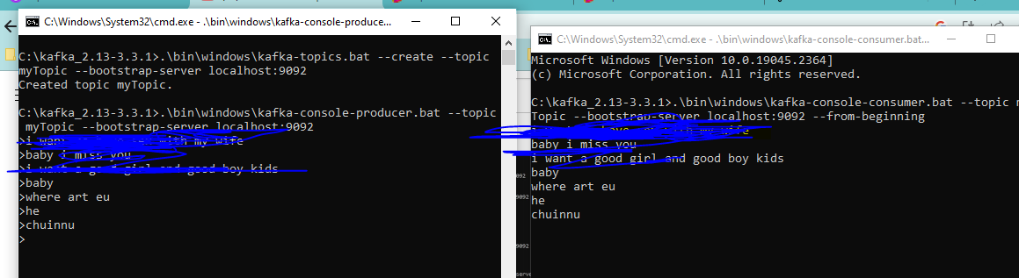

## 6. Console consumer in a group

.\bin\windows\kafka-console-consumer.bat --bootstrap-server localhost:9092 --topic stock-tips --from-beginning --group group1

### 7. analyze the dump using below



Installing multi node cluster

Go to kafka config folder and make 3 copies of server.property file

(in C:\kafka_2.13-3.3.1\config)

So that every time u start kafka server we can provide different serer file

C:\kafka_2.13-3.3.1>bin\windows\kafka-server-start.bat config\server-0.properties

C:\kafka_2.13-3.3.1>bin\windows\kafka-server-start.bat config\server-1.properties

C:\kafka_2.13-3.3.1>bin\windows\kafka-server-start.bat config\server-2.properties

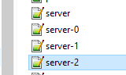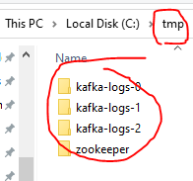

Every broker should have a different broker id, which makes broker unique

1. So open each broker and edit the below broker.id field and for 3 servers u will see 3 folders

**broker.id=1**

in realtime we will have multiple brokers /cluster of brokers, each will run on different node

1. so open each server.properties file and change the port , so that they will be running separately

listeners=PLAINTEXT://:9093

all 3 brokers will listen to 3 different ports and with these they will start on different nodes

1. when you are running multiple broker , each broker should have different log location

do change values as

open **server-o.properties** file and do the modification

log.dirs=**/tmp/kafka-logs-0**

# initially it would be log.dirs=**/tmp/kafka-logs**

open server-1.properties file and do the modification

log.dirs=/tmp/kafka-logs-1

open server-2.properties file and do the modification

log.dirs=/tmp/kafka-logs-2

1. The only problem with above is the above will create these file in c:temp

So now change them as

1 ) make below changes in server.properties file

log.dirs=../tmp/kafka-log-*

initially there is no double dot,whereas double dot means current directory

so from intellij u will run these commands so then and there itself in that folder these files will be created

1. open zookeeper.properties

dataDir=../tmp/zookeeper

after doing that first start zookeeper and then start kafka server with 1st property file and then start second kafka server with second property file

### Change everything to current directory

1. create an environment variable called KAFKA_HOME because to run the below command given by udemy sir prasanth, we should have set the variable and set as below

C:\kafka_2.13-3.3.1>setx KAFKA_HOME C:\kafka_2.13-3.3.1

SUCCESS: Specified value was saved.

this will set to user variables instead to a global variable

In this command only we will use the environment variable %KAFKA_HOME%\bin\windows\kafka-server-start.bat %KAFKA_HOME%\etc\kafka\server-0.properties

### **Cfg Batch scripts plugin in intellij**

You should be able to run the .cmd files from intellij idea

if u can’t run the command then install a plugin in intellij named “**Batch scripts support**”

The pro

